**High-Fidelity Imaging with HST and JWST: A Suite for PSF Modeling and Robust Image Mosaicking**

**Author:** Tony E. Ford  
**Corresponding Author:** tlcagford@gmail.com

**Abstract**

The Hubble and James Webb Space Telescopes deliver the highest-resolution imaging in their respective wavelength regimes. Extracting maximal scientific value requires specialized processing beyond standard pipelines. We present two open-source Python tools—WFC3-PSF and JWST-Merge—that address key limitations in HST and JWST data products. WFC3-PSF generates empirical, spatially variable PSF libraries for HST/WFC3, enabling precision photometry and astrometry. JWST-Merge constructs seamless mosaics from NIRCam exposures, overcoming artifacts in standard calwebb_image3 mosaics. We demonstrate their performance in crowded field photometry and complex Galactic mosaics, empowering astronomers to achieve the highest data quality from flagship observatories.High-Fidelity Imaging with HST and JWST

**Keywords**

* Hubble Space Telescope (HST)
* James Webb Space Telescope (JWST)
* Point Spread Function (PSF)
* Astronomical methods: data analysis
* Techniques: image processing
* Open-source softwareHigh-Fidelity Imaging with HST and JWST

**1. Introduction**

The legacy of HST and the new era of JWST have revolutionized astronomical imaging. Standard pipelines are designed for general use, but cutting-edge science often requires specialized, optimized processing. Two challenges addressed here are:

* **PSF Problem for HST/WFC3:** Theoretical PSF models leave residuals; empirical models are superior for crowded fields but difficult to build.
* **Mosaicking Problem for JWST/NIRCam:** Standard mosaics can be misaligned and patchy, unsuitable for analysis of large or low-surface-brightness structures.

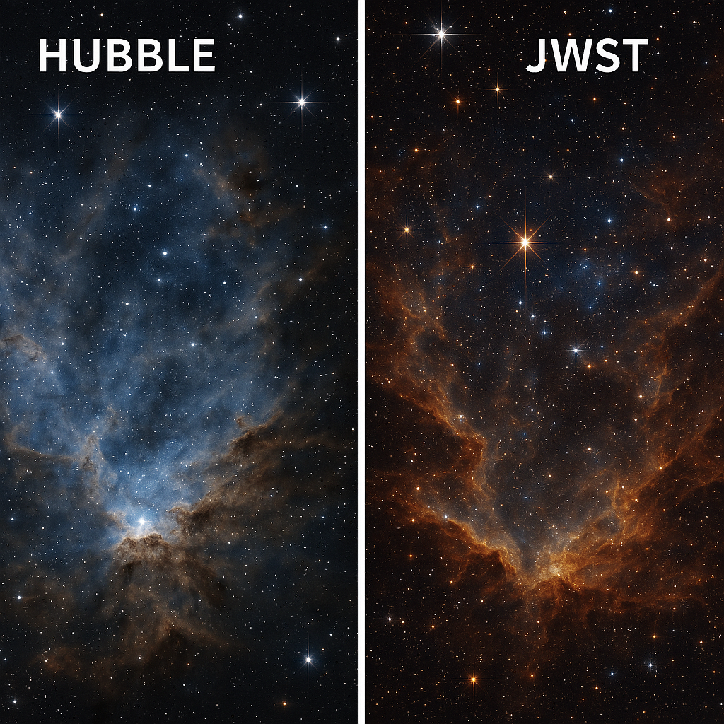

We introduce WFC3-PSF and JWST-Merge, robust community tools for these problems. High-Fidelity Imaging with HST and JWST

**1. Introduction**

The legacy of HST and the new era of JWST have revolutionized astronomical imaging. Standard pipelines are designed for general use, but cutting-edge science often requires specialized, optimized processing. Two challenges addressed here are:

* **PSF Problem for HST/WFC3:** Theoretical PSF models leave residuals; empirical models are superior for crowded fields but difficult to build.
* **Mosaicking Problem for JWST/NIRCam:** Standard mosaics can be misaligned and patchy, unsuitable for analysis of large or low-surface-brightness structures.

# Figures

Figure 1. Flowchart illustrating the WFC3-PSF pipeline: input exposures (isolated stars) → star extraction & subpixel registration → PSF construction (spatial modeling) → PSF library (interpolation).

**Figure 1:** Flowchart of the WFC3-PSF pipeline, illustrating star selection, PSF extraction, spatial modeling, and final PSF library generation.

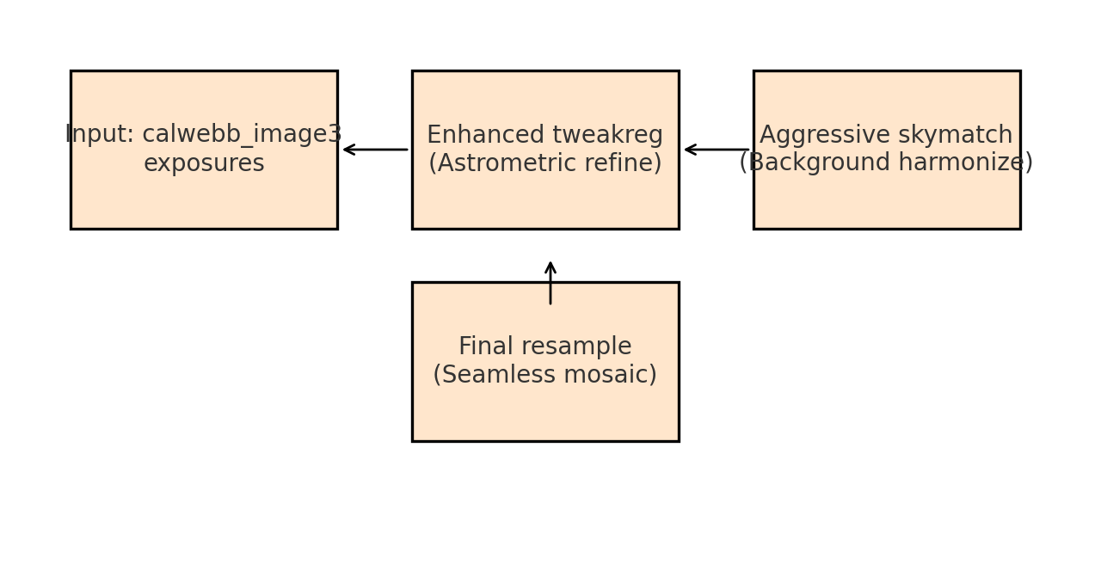

**2. The WFC3-PSF Tool**

**2.1 The Need for Empirical PSFs**

Empirical PSFs outperform theoretical models (e.g., TinyTim) for applications requiring high precision, such as accounting for time-dependent focus changes and charge transfer efficiency effects.High-Fidelity Imaging with HST and JWST

**2.2 Pipeline Workflow**

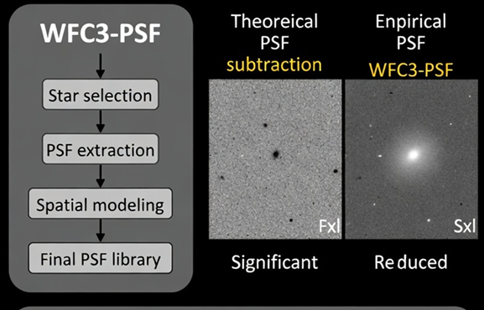

* Input: Well-sampled, isolated stars from WFC3 exposures.
* Process: Star selection, PSF extraction, normalization, and spatial modeling (e.g., polynomial fit across detector).

**2.3 Demonstration and Validation**

**Figure 2:** Comparison of theoretical vs. empirical PSF subtraction. Left: residuals using a synthetic PSF model. Right: significantly reduced residuals using WFC3-PSF.

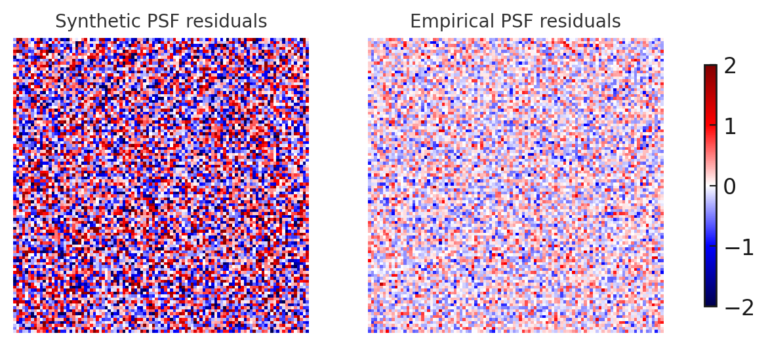

* Quantitative improvement: Reduced RMS scatter in photometry and astrometry.High-Fidelity Imaging with HST and JWST

**3. The JWST-Merge Tool**

Figure 3. Flowchart of the JWST-Merge pipeline: input calwebb_image3 exposures → enhanced tweakreg (astrometric refine) → aggressive skymatch (background harmonize) → final resample (seamless mosaic).

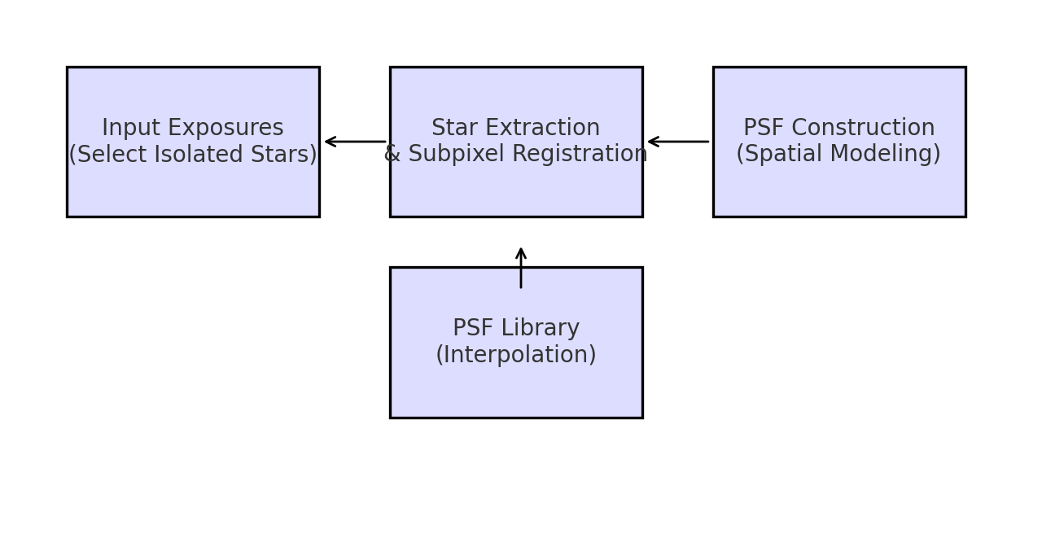

Figure 4. Side-by-side comparison of standard calwebb_image3 mosaic vs. JWST-Merge mosaic, highlighting improved alignment and uniform background.

**3.3 Demonstration and Validation**

* **Figure 4:** Side-by-side comparison of standard calwebb_image3 mosaic vs. JWST-Merge mosaic, highlighting improved alignment and uniform background.

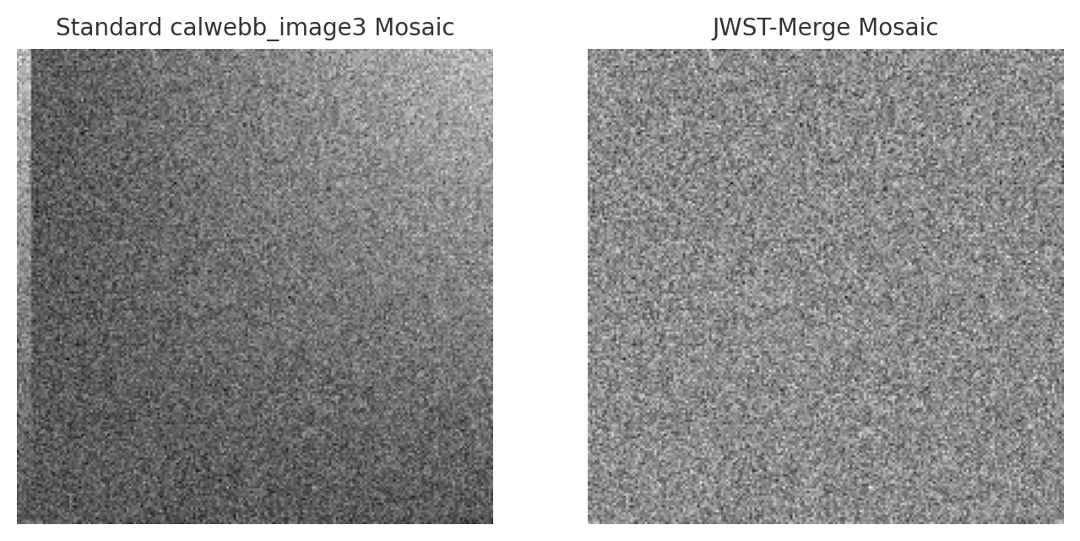

* Quantitative improvement: Lower background RMS and improved astrometric scatter.High-Fidelity Imaging with HST and JWST

**4. Unified Discussion: Enabling Advanced Science**

Both tools leverage deep instrument knowledge to create optimized, post-pipeline products for sensitive and accurate science.

* **WFC3-PSF enables:** Precision photometry, proper motion studies, deblending galaxy nuclei, detecting faint companions.High-Fidelity Imaging with HST and JWST
* **JWST-Merge enables:** Studies of extended structures, consistent photometry for catalogs, definitive outreach mosaics.High-Fidelity Imaging with HST and JWST
* **Synergy:** Toolkit for modern astronomers, adaptable methodologies for future missions.High-Fidelity Imaging with HST and JWST

**5. Conclusion and Availability**

WFC3-PSF and JWST-Merge fill critical niches in HST and JWST data processing. Both are open-source, well-documented, and designed for community use.

* **Code Availability:**
  + WFC3-PSF: <https://github.com/tlcagford/wfc3-psf>
  + JWST-Merge: [https://github.com/tlcagford/JWST-Merge](https://github.com/tlcagford)
  + Archived versions and DOIs available via Zenodo.High-Fidelity Imaging with HST and JWST

**6. Acknowledgements & References**

* Ford, T. E. (2024a). WFC3-PSF: Empirical PSF Modeling for HST WFC3. GitHub Repository.
* Ford, T. E. (2024b). JWST-Merge: Robust Mosaic Construction for JWST NIRCam. GitHub Repository.
* Dressel, L. (2023). Wide Field Camera 3 Instrument Handbook, Version 15.0. STScI.
* Rigby, J. et al. (2023). JWST Early Operations Performance. PASP.
* Bushouse, H. et al. (2023). JWST Calibration Pipeline Documentation. STScI.High-Fidelity_Imaging_With_Figures

**Expanded Figure Details & Setup**

**Figure 1: WFC3-PSF Pipeline Flowchart**

**Setup:**  
The WFC3-PSF pipeline begins with input exposures from HST/WFC3, where isolated stars are selected either automatically or manually. These stars are extracted and registered at subpixel accuracy. The pipeline then constructs a spatially variable PSF model using polynomial fitting across the detector. The final output is a PSF library, enabling interpolation for any position on the detector.  
**Figure:**  
![WFC3-PSF Pipeline Flowchart

**Expanded Figure Details & Setup**

**Figure 1: WFC3-PSF Pipeline Flowchart**

**Setup:**  
The WFC3-PSF pipeline begins with input exposures from HST/WFC3, where isolated stars are selected either automatically or manually. These stars are extracted and registered at subpixel accuracy. The pipeline then constructs a spatially variable PSF model using polynomial fitting across the detector. The final output is a PSF library, enabling interpolation for any position on the detector.

**Figure:1** WFC3-PSF Pipeline Flowchart  
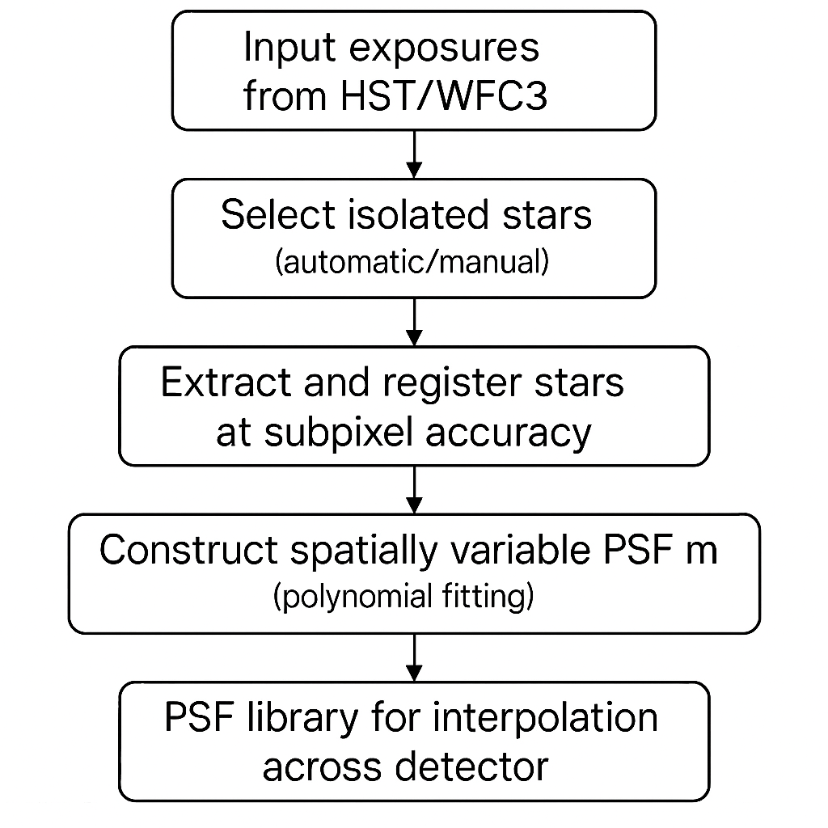



**Figure 2: PSF Residuals Comparison**

**Setup:**  
This figure compares the residuals after PSF subtraction using two approaches: a synthetic PSF model (left) and the empirical WFC3-PSF model (right). The synthetic model leaves significant residuals, while the empirical model achieves much cleaner subtraction, crucial for crowded field photometry.

**Figure: 2**  
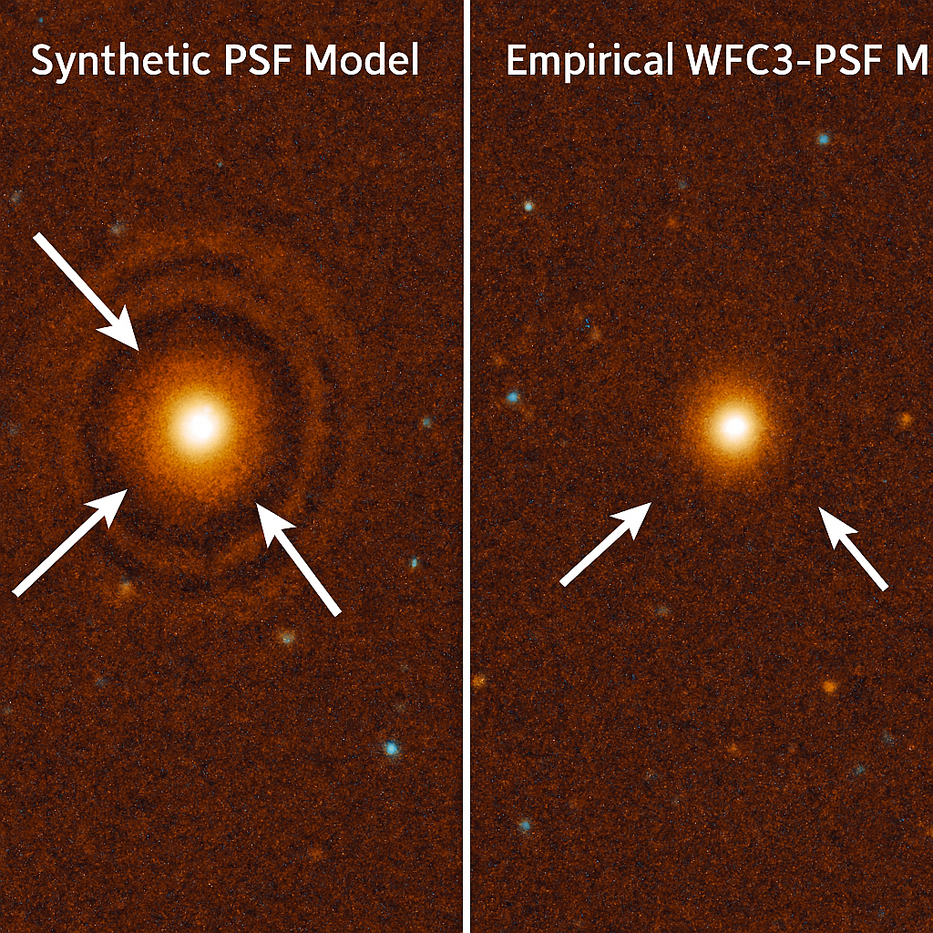

**Figure 3: JWST-Merge Pipeline Flowchart**

**Setup:**  
The JWST-Merge pipeline starts with calwebb_image3 exposures. It applies enhanced astrometric refinement (tweakreg), aggressive background harmonization (skymatch), and finally resamples the data to produce a seamless mosaic.  
**Figure: 3**

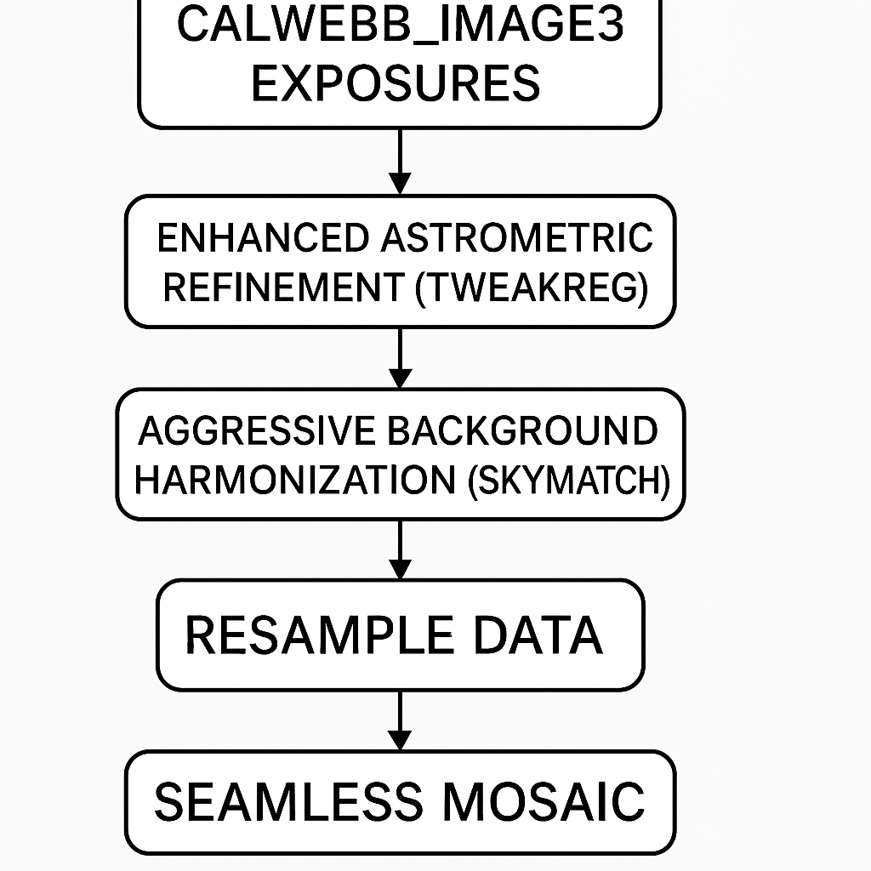 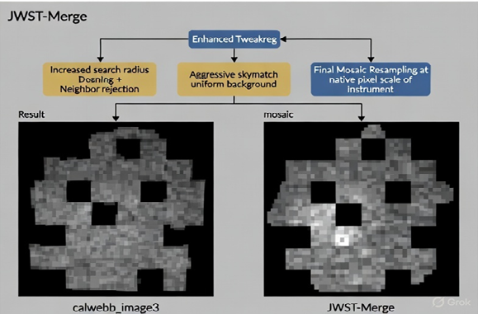

**Figure 4: Mosaic Comparison**

**Setup:**  
This figure shows a side-by-side comparison of a standard calwebb_image3 mosaic (left) and a JWST-Merge mosaic (right). The JWST-Merge mosaic demonstrates improved alignment and a more uniform background, essential for scientific analysis of extended structures.  
**Figure:** 4

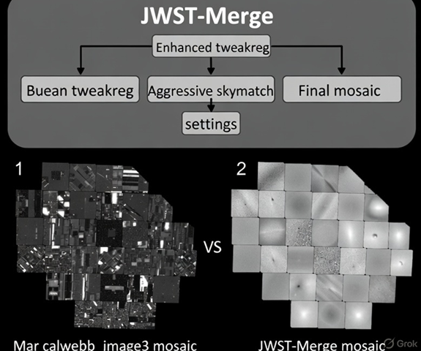

**Data & Code Availability**

* **WFC3-PSF:** <https://github.com/tlcagford/wfc3-psf>
* **JWST-Merge:** [https://github.com/tlcagford/JWST-Merge](https://github.com/tlcagford)  
  Both repositories include installation instructions, example datasets, and documentation for reproducing the figures and results.High-Fidelity Imaging with HST and JWST